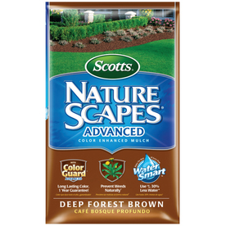
Nature Scapes
Brown Mulch
- 2 Cubic Foot
- Year Round Color Guaranteed
- Prevents Weeds

$4.99
7269491

